Hockey Registration Form
2020 -2021 Season
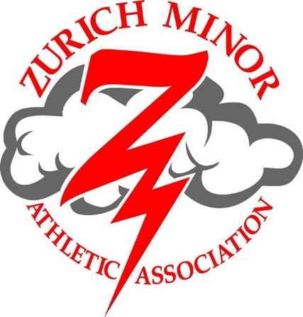
Zurich Minor Athletic Association
Hockey Registration Form
2020-2021 Season
1. Parent or Guardian Information:

Parents’ or Guardians’ names: _______________________________________________________

Mailing Address: ___________________________________________________________________

Town: _____________________________ Postal Code: ___________________________________

Telephone #: _________________________________ E-mail (please): _______________________

Municipality _______________________________________________________________________

2. Fundraising:
Due to COVID-19, ZMAA was not able to fundraise with Bean Fest this year, and may not be able to participate in any other fundraising initiatives this season. Parents/Guardians will not be required to issue a fundraising cheque with their 2020/2021 registration, but we ask that Parents/Guardians be prepared to volunteer their time, be it screening at the door, or any other capacity in relation to new pandemic protocols.

Would you be willing to or know someone that would like to help as a:
Coach / Manager / Trainer / on–ice helper / Executive Member / Director?
Name : __________________________________ Age level that you would like to help with: ________
Are you CPR certified? ___ Yes ___ No Are you First Aid certified? ___ Yes ___ No
PLAYER INFORMATION
(for age group see page 4)

Player #1
NAME __________________________________________ AGE GROUP ______________________

BIRTHDATE (M/D/Y) ________________________________ M ( ) F ( )
Photo Release
____________ I hereby grant permission for digital photographs and video recordings to be taken
(parent initial’s) of my child as part of his/her participation in Zurich Minor Athletic Association
(ZMAA) activities and to be shared on the ZMAA Facebook page and/or
Zurich Minor Athletic Association website.
Player #2
NAME __________________________________________ AGE GROUP ______________________

BIRTHDATE (M/D/Y) ________________________________ M ( ) F ( )
Photo Release
____________ I hereby grant permission for digital photographs and video recordings to be taken
(parent initial’s) of my child as part of his/her participation in Zurich Minor Athletic Association
(ZMAA) activities and to be shared on the ZMAA Facebook page and/or
Zurich Minor Athletic Association website.
Player #3
NAME __________________________________________ AGE GROUP ______________________

BIRTHDATE (M/D/Y) ________________________________ M ( ) F ( )
Photo Release
____________ I hereby grant permission for digital photographs and video recordings to be taken
(parent initial’s) of my child as part of his/her participation in Zurich Minor Athletic Association
(ZMAA) activities and to be shared on the ZMAA Facebook page and/or
Zurich Minor Athletic Association website.
Player #4
NAME __________________________________________ AGE GROUP ______________________

BIRTHDATE (M/D/Y) ________________________________ M ( ) F ( )
Photo Release
____________ I hereby grant permission for digital photographs and video recordings to be taken
(parent initial’s) of my child as part of his/her participation in Zurich Minor Athletic Association
(ZMAA) activities and to be shared on the ZMAA Facebook page and/or
Zurich Minor Athletic Association website.

Respect in Sport Parent Program
** Please note only FIRST TIME hockey families need to complete the course this season **
This online course is mandatory per household. Don’t delay. Non-completion of this course will result in your player(s) not receiving OMHA approval to play on any teams.
The Respect in Sport Program for Parents is a unique, in-depth 1-hour online program geared to providing parents with information on how to evaluate and understand:
- Parental influence over a child - Coach and leader roles in sport
- Role of the parent and coach in ensuring a child’s enjoyment of a sport
- Concussion awareness and ‘Return to Play’ guidelines - Long-Term Player Development
Go to https://omhahockeyparent.respectgroupinc.com/secure/ to complete the course.
Certificate Number _______________________________________ (Mandatory for Registration to be accepted). There is a cost of approximately $15.00 that is to be paid online by the parent.

New Hockey Registrants of ZMAA: Please include a photocopy of your child’s Birth Certificate with this form. New players’ names and birthdates must also be added to your previously completed Respect in Sports.
 | Description | Cost on Oct. 15, 2020
U7 (Initiation Program) | 2017 & 2016 & 2015 & 2014  $250  (OMHA allows practices only for players under age 5)
U8 (Minor Novice) | 2013 | $350.00
U9 (Major Novice) | 2012 | $350.00
U11 (Atom) | 2010 & 2011 | $400.00
U13 (PeeWee) | 2008 & 2009 | $400.00
Goalies | ZMAA provides pads and blockers to goalies peewee age and below | Per age group above

Payment Totals:
Child # 1 Registration Fee | $
Child # 2 Registration Fee | $
Child # 3 Registration Fee | $
Child # 4 Registration Fee | $
Total:  Payment options: by cheque or eTransfer  *PAYMENT DUE ON OR BEFORE OCT. 15, 2020* | 1) Cheque made payable to:  Zurich Minor Athletic Association or ZMAA  Mailed to: ZMAA, c/o Kim Grainger, 74265 Bluewater Hwy., Zurich, ON. N0M 2T0  There will be a $25.00 fee for NSF cheques  2) eTransfer email: zmaatreasurer@gmail.com

