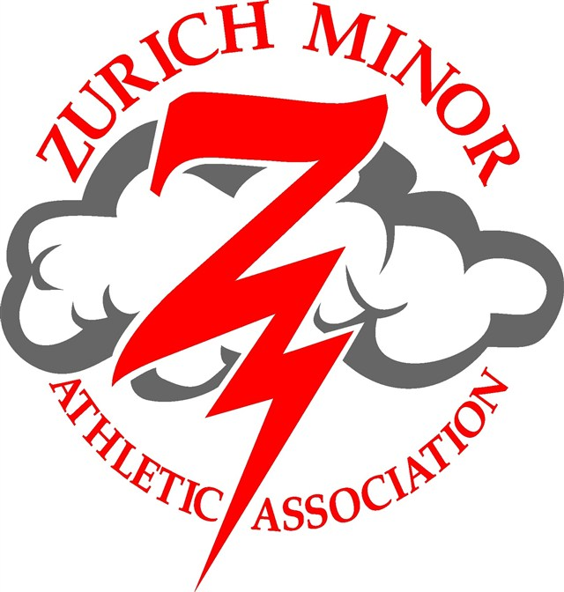

Hockey Registration Form
2017-2018 Season

Registration Date and Time:

There will only be one walk-in registration time:
Friday April 7th @ 6:00PM at the Zurich Arena in the auditorium.

An opportunity to sign up for Bean Fest shifts will also be available during registration on a first come-first served basis.

If you cannot be at registration, you may give it to another family to bring.

After April 7th, registrations can be submitted to:

Pete Overholt
72823 Cantin Court
RR#2, Zurich, Ontario
N0M2T0
poverholt12@gmail.com

ZMAA is pleased to offer local league hockey for all ages this year!

We will not be offering Rep hockey for the 2017-2018 season. Please indicate on your registration form if your child intends to try out for a rep team at another centre. This will assist with team planning. Should you have any questions, please contact poverholt12@gmail.com.

Please spread the word about our great organization. We offer prime ice times in a new arena with comparatively low registration fees. Visit our website @ www.zurichminorhockey.ca

Zurich Minor Athletic Association
Hockey Registration Form
2017-2018 Season
1. Parent or Guardian Information:

Parents’ or Guardians’ names: ______________________________________________________

Mailing Address: ________________________________________________________________

Town: _____________________________ Postal Code: _________________________________

Telephone #: ____________________ E-mail (please): __________________________________

Do you have SMART SERVE? ___ Yes ____ No Server Name: ______________________

For new families or families who have moved since June 2016 ONLY: Lot & Concession (rural) or House Number & Street name (town)
__________________________________________________________________________________
Municipality:_________________________

2. Fund raising requirements:

Each family is required to work 6-8 hours at the Zurich Bean Festival on August 26, 2017 and will depend on scheduling needs. Shifts are filled on a first come-first served basis, not on what your shift was last year. You will sign up for your shift at the registration on April 7th. Registrations received after this will be assigned a shift-you will not be able to choose.

Name(s) of participating parents/guardians: (18 years or older)

1.__________________________________ 2.________________________________________

A Z.M.A.A. Bean Fest Representative will be contacting you about your shift. Please remember your obligation to help out. The registration fees do not completely cover the costs associated with hockey. These fundraising activities help us keep hockey affordable to all.

A cheque for $ 300.00, post-dated for Sept 30, 2017 is required. It will only be cashed if your volunteer Bean Fest fundraising requirement is not fulfilled.

Would you be willing to or know of someone that would like to help as a

Coach / Manager / Trainer / on -ice helper / Director?

NAME: _________________________ Age level that you would like to help with: ______________________

Are you CPR certified? ( ) YES ( ) NO
Are you First Aid certified? ( ) YES ( ) NO

PLAYER INFORMATION
(for age group see pg. 4)
Player # 1
NAME _______________________ AGE GROUP _______________________

BIRTHDATE (M/D/Y) __________________________ M ( ) F ( )
______________________________________________________________________
Player # 2
NAME _______________________ AGE GROUP _______________________

BIRTHDATE (M/D/Y) __________________________ M ( ) F ( )
___________________________________________________________________________
Player # 3
NAME _______________________ AGE GROUP _______________________

BIRTHDATE (M/D/Y) __________________________ M ( ) F ( )
___________________________________________________________________________
Player # 4
NAME _____________________ AGE GROUP _______________________

BIRTHDATE (M/D/Y) __________________________ M ( ) F ( )

___________________________________________________________________________________________

RESPECT IN SPORT PARENT PROGRAM

** Please note only FIRST TIME hockey families need to complete the course this season **

This online course is mandatory per household. Don't delay. Non-completion of this course will result in your player(s) not receiving OMHA approval to play on any teams.
The Respect in Sport Program for Parents is a unique, in-depth 1-hour online program geared to providing parents with information on how to evaluate and understand:
- Parental influence over a child
- Coach and leader roles in sport
- Role of the parent and coach in ensuring a child's enjoyment of a sport
- Protecting your child when outside of your immediate control
- Concussion awareness and 'Return to Play' guidelines
- Long-Term Player Development

Go to https://omhahockeyparent.respectgroupinc.com/secure/ to complete the course.
Certificate Number ______________________________ (Mandatory for Registration to be accepted)
There is a cost of $13.56 that is to be paid online by the parent

New Hockey Registrants of ZMAA: Please include a photocopy of your Birth Certificate with this form. Players will not be allowed on the ice without a completed registration form, payment and a photocopy of the child’s birth certificate. New players’ names and birthdates must also be added to your previously completed Respect In Sports

 | Description |  | Cost ON April 7th, 2017
Initiation Program | 2012-2014 |  | $250.00
Tyke | 2011 |  | $250.00
Novice | 2009 & 2010 |  | $475.00
Atom | 2007 & 2008 |  | $475.00
Peewee | 2005 & 2006 |  | $475.00
Bantam | 2003 & 2004 |  | $475.00
Midget | 2000 & 2001 & 2002 |  | $475.00
Goalies | ZMAA provides pads and blockers to goalies peewee age & below | Per age group above  ↑↑ | Per age group above ↑↑
Goalies | Bantam & above |  | $250.00

Payment Totals:
Child # 1 Registration Fee | $
Child # 2 Registration Fee | $
Child # 3 Registration Fee | $
Child # 4 Registration Fee | $
Total: | $_________________  Cheque’s are made payable to:  Zurich Minor Athletic Association or ZMAA  **There will be a $25.00 fee for NSF cheques **
Registration Total: You may date the cheque for October 15, 2017 | $
Fund Raising Cheque – Will only be cashed if you do not fulfill your Bean Fest shift requirements | $300.00 Dated September 15/2017  ( A separate cheque)

If necessary, you may divide the registration total into 2 equal payments with 2 post-dated cheques with the following dates (these cheques must accompany the registration form): If you have 3 or more children you can make 3 post dated cheques, first payment being July 15, 2017

Cheque Dated September 15, 2017 $__________________
Cheque Dated November 15, 2017 $__________________
Cheque Dated July 15, 2017 $________________________ ( if 3 or more children )

Waiver Form for Zurich Minor Athletic Association Sports
(To Be Used for Players UNDER the Age of 18)

Parent/ Guardian names: _______________________________________________

First Name(s) AND Ages of All Participating Children:

_______________________________ _________________________________

_______________________________ _________________________________

ALL PROGRAMS AND ACTIVITIES HAVE ITS RISKS:
I allow my child to participate in the game of hockey because it is physically and mentally challenging. In consideration of my child’s participation in such programs, activities and events, I hereby acknowledge that I am aware of the risks and hazards associated with or related to this activity. The risks and hazards include, but are not limited to:
. Injuries from executing strenuous and demanding physical techniques in hockey;
. Injuries from ice surfaces and dressing rooms including bacterial infections and rashes;
. Injuries resulting from falls to the ground due to uneven or irregular terrain or ice surfaces;
. Injuries from collisions with walls and hockey equipment;
. Injuries resulting from failure to properly use any piece of equipment or from the mechanical failure of any piece of equipment;
. Spinal cord injuries which may render my child permanently paralyzed;.
. Injuries from contact, colliding or being struck by other participants, spectators, equipment or vehicles;
. Injuries resulting from vigorous physical exertion and strenuous cardiovascular workouts;
. Injuries from exerting and stretching various muscle groups; and
. Travel to and from competitive events and associated non-competitive events which are an integral part of the organization’s activities.
Furthermore, I am aware:
. That injuries sustained in hockey can be severe;
. That my child may experience anxiety while challenging him/herself during the activities;
. That my child may come into close contact with other participants, including the possibility of accidental and unexpected contact;
. That risk of injury is reduced if my child follows all rules established for participation; and
. That my child’s risk of injury increases as he/she becomes fatigued.
Website:
I also allow my child’s/children’s picture and name (including surname) to be posted on our website and I also understand they may be mentioned in an article on the Zurich Minor Hockey website.

I AGREE TO BE RESPONSIBLE FOR MY CHILD:
My child is participating voluntarily in these activities, events and programs. I agree that there are risks in hockey as described above. By participating voluntarily in these events, activities and programs, I am exposing my child to these risks and hazards. I agree to accept them and be responsible for any injury or other loss which my child might receive while participating in these events, activities and programs.
If something happens to my child, I release the organizers of responsibility for any claims, demands, actions and costs which might arise out of my participation. In this Agreement I understand organizers to mean: the Zurich Minor Athletic Association and its directors and employees, all member Leagues and Clubs, their directors, officers, members, employees, volunteers, officials, participants, clubs, agents, sponsors, owners/operators of facilities and their representatives.
I ACKNOWLEDGE MAKING THIS AGREEMENT:
I have read and understood the terms and conditions of this agreement, and by signing it voluntarily, I am agreeing to abide by these terms. By signing this form you give up important legal rights. Please read carefully!

_____________________________________
Printed Name of Parent or Guardian

_____________________________________
Signature of Parent or Guardian
______________________________
Date

